Project Title:
Canteen Management System
Problem Specification:
The problem in focus is the management of canteen which involves various challenges related to food ordering ,inventery management and uptodate menu.
Targeting Person:
Our targeting persons are canteen staff , university students, faculty, or colleges, office workers , and
where effective canteen management needs can use
it.
Main Features OF Project:
- Menu Management (canteen staff to create and manage the menu items, including their prices, descriptions and availability)
- Ordering(allow users to view the menu ,select items and customize orders).
- Inventory Management(The system should keep
track of the inventory of ingredients and other food items in the canteen it should update the inventory levels based on food orders and generate alerts or notification when stock runs slow).
2.Analysis:
Input:
- Food orders placed by customers which may include details such as menu items , quantities and prices.
- Inventory data such as the availability and quantities of ingredients and other food items in the canteen. • Menu item data, such as prices, descriptions and
availability.
Output:
- Total cost of food order
- Reports and analytics on various aspects of canteen operations, such as sales, revenue , inventory usage.
- Alerts or notification s for low inventory levels or other important events.
Main Formulas:
- Calulation of total cost of food orders which may involve adding up the prices of menu items.
- Inventory management formulas such as tracking the usage of ingredients, updating inventory levels based on food orders, and generating alerts for low inventory levels.
For Example:
Reordering formula:
Reorder Point=Average Daily Usage*lead time for
Replenishment.
Flow Chart Or Algorithm:
The flow chart or algorithm of canteen management system is as follows:
  - Start
  - Customer enters canteen
  - Customer selects items from menu
  - Customer places order
  - Order is processed
  - Food is prepared
  - Food is served to customer
  - Customer pays for food
  - Customer leaves canteen
  - End
The flow chart or algorithm can be further broken down into the following steps:
  - Customer enters canteen o Customer scans their ID card or enters their name and contact information o Customer selects items from menu o Customer places order
  - Order is processed o Order is entered into system o Order is assigned to a cook o Cook prepares food
  - Food is prepared
o Food is cooked according to recipe o Food is plated o Food is garnished
  - Food is served to customer o Food is delivered to customer o Customer pays for food
  - Customer leaves canteen o Customer leaves canteen
The flow chart or algorithm can be used to design a canteen management system. The system can be implemented using a variety of technologies, such as a web application, a mobile app, or a point-of-sale system.
Here are some additional considerations for designing a canteen management system:
- Security: The system must be secure to protect customer data and financial information.
- Usability: The system must be easy to use for both customers and staff.
- Scalability: The system must be able to scale to accommodate a growing number of customers and staff.
- Flexibility: The system must be flexible enough to accommodate changes in menu items, prices, and other factors.

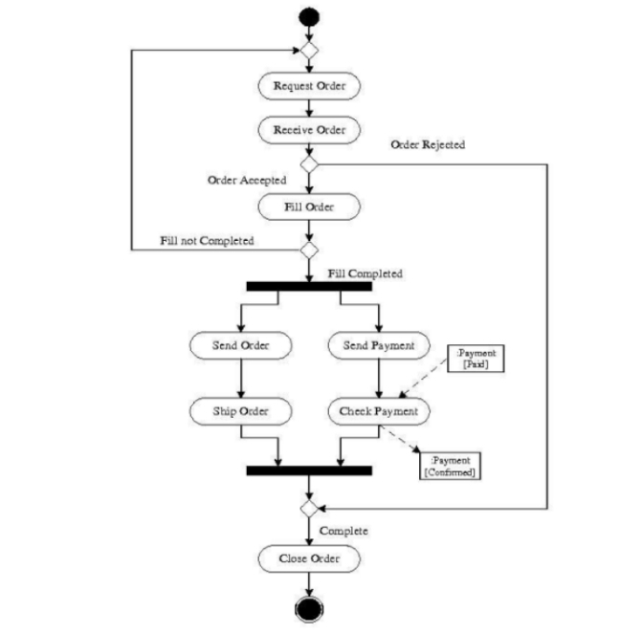

- Project Code:
#include <iostream>
#include <fstream>
using namespace std;

class Order {
private:
string name;
int choice;
int pchoice;
int pchoice1;
int quantity;
int totalBill;
double fullTotal;
public:
void displayMenu() {
cout << "\t\t\t----------PAF-IAST STC-----------\n\n";
cout << "\t\t\t\t--------Menu--------\n\n";
cout << "1) Pizzas\n";
cout << "2) Burgers\n";
cout << "3) Sandwich\n";
cout << "4) Rolls\n";
cout << "5) Biryani\n\n";
}

void processOrder() {
bool orderAgain = true;
bool validChoice = true;

do {
displayMenu();
cout << "Please Enter your Choice: ";
cin >> choice;

switch (choice) {
case 1:
processPizzaOrder();
break;
case 2:
processBurgerOrder();
break;
case 3:
processSandwichOrder();
break;
case 4:
processRollOrder();
break;
case 5:
processBiryaniOrder();
break;
default:
cout << "Invalid choice! Please select a valid option.\n";
validChoice = false;
break;
}

if (validChoice) {
displayOrderSummary();
cout << "\nWould you like to order anything else? (Y/N): ";
char again;
cin >> again;

if (again == 'Y' || again == 'y') {
orderAgain = true;
} else {
orderAgain = false;
displayFinalOrder();
saveOrderToFile();
}
} else {
orderAgain = true;
}
} while (orderAgain);

cout << "\nThank you for your order, " << name << "! Enjoy your meal.\n";
}

void processPizzaOrder() {
cout << "\n1) Chicken Fazita\n";
cout << "2) Chicken Bar BQ\n";
cout << "3) Peri Peri\n";
cout << "4) Creamy Max\n";
cout << "\nPlease Enter which Flavor would you like to have?: ";
cin >> pchoice;

if (pchoice >= 1 && pchoice <= 4) {
cout << "\n1) Small Rs.250\n" << "2) Regular Rs.500\n" << "3) Large Rs.900\n";
cout << "\nChoose Size Please: ";
cin >> pchoice1;

if (pchoice1 >= 1 && pchoice1 <= 3) {
cout << "\nPlease Enter Quantity: ";
cin >> quantity;

switch (pchoice1) {
case 1:
displayOrder("Chicken Fazita", 250);
break;
case 2:
displayOrder("Chicken Bar BQ", 500);
break;
case 3:
displayOrder("Peri Peri", 900);
break;
}
}
}
}

void processBurgerOrder() {
cout << "\n1) Zinger Burger Rs.180\n";
cout << "2) Chicken Burger Rs.150\n";
cout << "3) Beef Burger Rs.160\n";
cout << "\nPlease Enter which Burger you would like to have?: ";
cin >> pchoice1;

if (pchoice1 >= 1 && pchoice1 <= 3) {
cout << "\nPlease Enter Quantity: ";
cin >> quantity;

switch (pchoice1) {
case 1:
displayOrder("Zinger Burger", 180);
break;
case 2:
displayOrder("Chicken Burger", 150);
break;
case 3:
displayOrder("Beef Burger", 160);
break;
}
}
}

void processSandwichOrder() {
cout << "\n1) Club Sandwich Rs.280\n";
cout << "2) Chicken Sandwich Rs.250\n";
cout << "3) Veggie Sandwich Rs.200\n";
cout << "\nPlease Enter which Sandwich you would like to have?: ";
cin >> pchoice1;

if (pchoice1 >= 1 && pchoice1 <= 3) {
cout << "\nPlease Enter Quantity: ";
cin >> quantity;

switch (pchoice1) {
case 1:
displayOrder("Club Sandwich", 280);
break;
case 2:
displayOrder("Chicken Sandwich", 250);
break;
case 3:
displayOrder("Veggie Sandwich", 200);
break;
}
}
}

void processRollOrder() {
cout << "\n1) Chicken Roll Rs.180\n";
cout << "2) Beef Roll Rs.150\n";
cout << "3) Vegetable Roll Rs.120\n";
cout << "\nPlease Enter which Roll you would like to have?: ";
cin >> pchoice1;

if (pchoice1 >= 1 && pchoice1 <= 3) {
cout << "\nPlease Enter Quantity: ";
cin >> quantity;

switch (pchoice1) {
case 1:
displayOrder("Chicken Roll", 180);
break;
case 2:
displayOrder("Beef Roll", 150);
break;
case 3:
displayOrder("Vegetable Roll", 120);
break;
}
}
}

void processBiryaniOrder() {
cout << "\n1) Chicken Biryani Rs.300\n";
cout << "2) Beef Biryani Rs.280\n";
cout << "3) Mutton Biryani Rs.350\n";
cout << "\nPlease Enter which Biryani you would like to have?: ";
cin >> pchoice1;

if (pchoice1 >= 1 && pchoice1 <= 3) {
cout << "\nPlease Enter Quantity: ";
cin >> quantity;

switch (pchoice1) {
case 1:
displayOrder("Chicken Biryani", 300);
break;
case 2:
displayOrder("Beef Biryani", 280);
break;
case 3:
displayOrder("Mutton Biryani", 350);
break;
}
}
}

void displayOrder(const string& item, int price) {
cout << "\n\n\t\t\t----------Order Details----------\n\n";
cout << "Customer Name: " << name << endl;
cout << "Item: " << item << endl;
cout << "Quantity: " << quantity << endl;
cout << "Price: Rs." << price << endl;
int totalItemBill = price * quantity;
totalBill = totalItemBill;
fullTotal += totalItemBill;
cout << "Item Total: Rs." << totalItemBill << endl;
}

void displayOrderSummary() {
cout << "\n\n\t\t\t----------Order Summary----------\n\n";
cout << "Customer Name: " << name << endl;
if (totalBill > 0) {
cout << "Total Bill: Rs." << totalBill << endl;
}
}

void displayFinalOrder() {
cout << "\n\n\t\t\t----------Final Order Summary----------\n\n";
cout << "Customer Name: " << name << endl;
cout << "Total Bill: Rs." << fullTotal << endl;
}

void saveOrderToFile() {
ofstream outputFile("order.txt", ios::app);

if (!outputFile) {
cout << "Error creating order file!" << endl;
return;
}

outputFile << "Customer Name: " << name << endl;
outputFile << "Total Bill: Rs." << fullTotal << endl;
outputFile << "------------------------" << endl;

outputFile.close();
cout << "Order details saved to file." << endl;
}

public:
void startOrder() {
cout << "Please Enter Your Name: ";
cin.ignore();
getline(cin, name);
processOrder();
}
};

int main() {
cout << "Welcome" << endl;
Order order;
order.startOrder();
return 0;
}

